Cosmos DB is a Planet base NOSQL Json Database with multi API support. As the name suggests universe. Cosmos DB is global scale data base which provides data synchronization throughout the planet. Data is stored in Jason format in Cosmos database. It provides multi API Support with includes SQL API, Mongo API, Graph API, Table API, cassandra API.

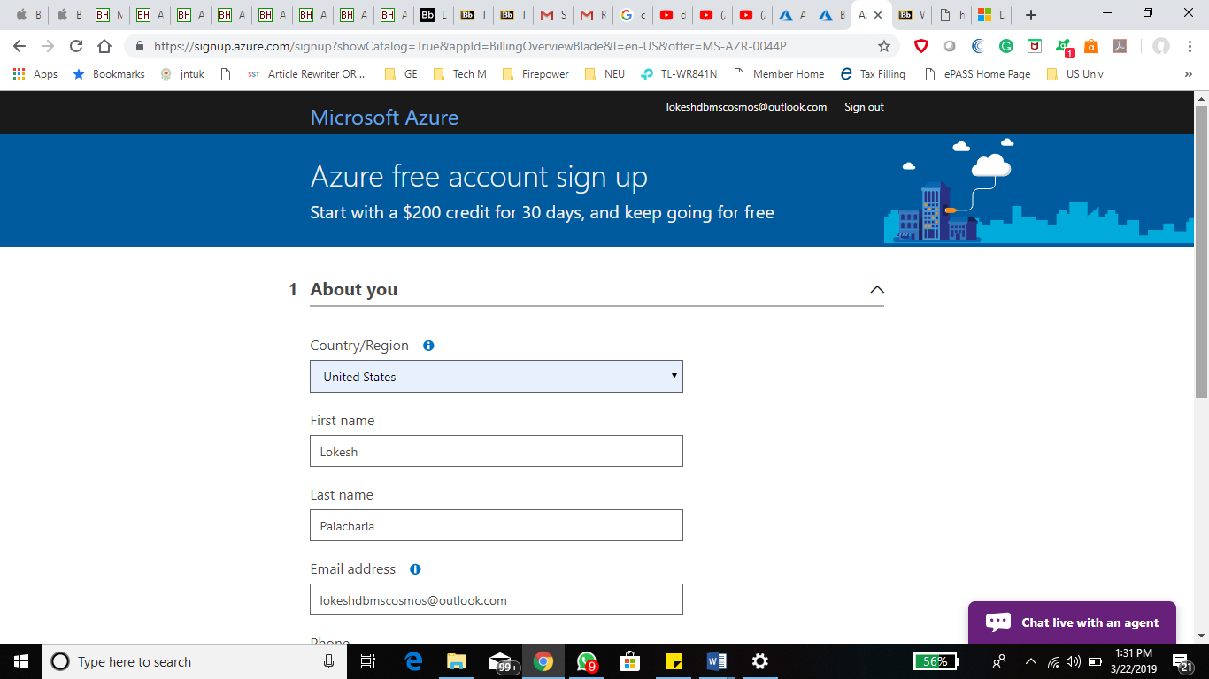

Creating a free Azure account for demo.

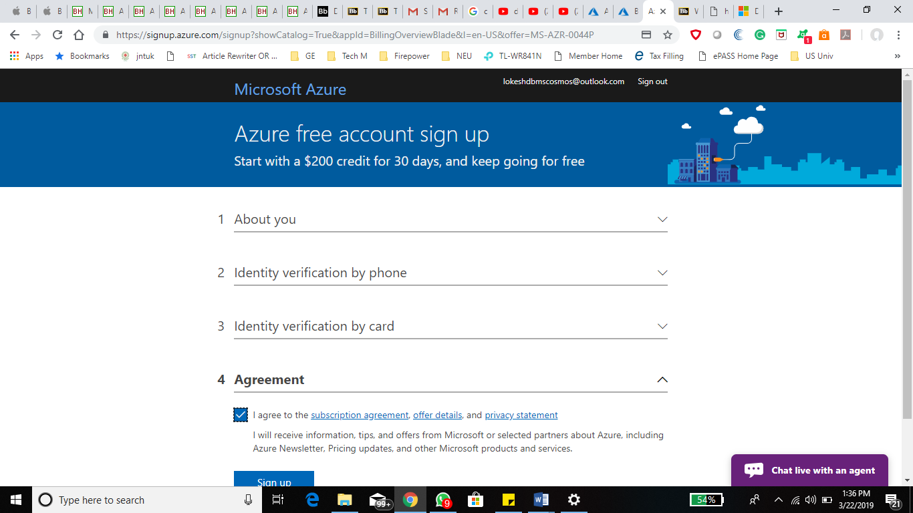

Select Azure cosmos DB from the menu on the left side of the screen.

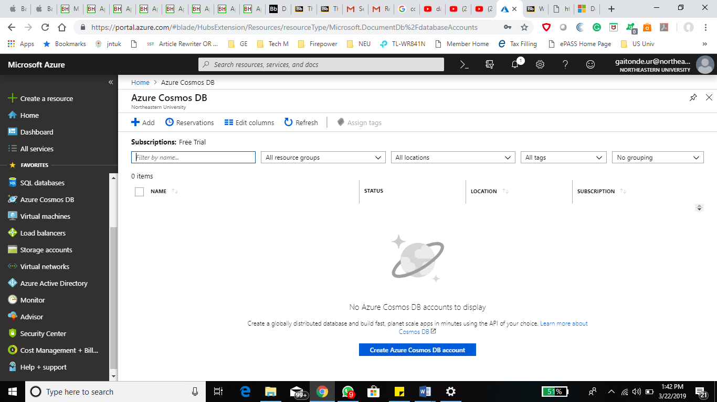

Cosmos DB provides Multi API Support. We can choose an API from the available list as in below snapshot.

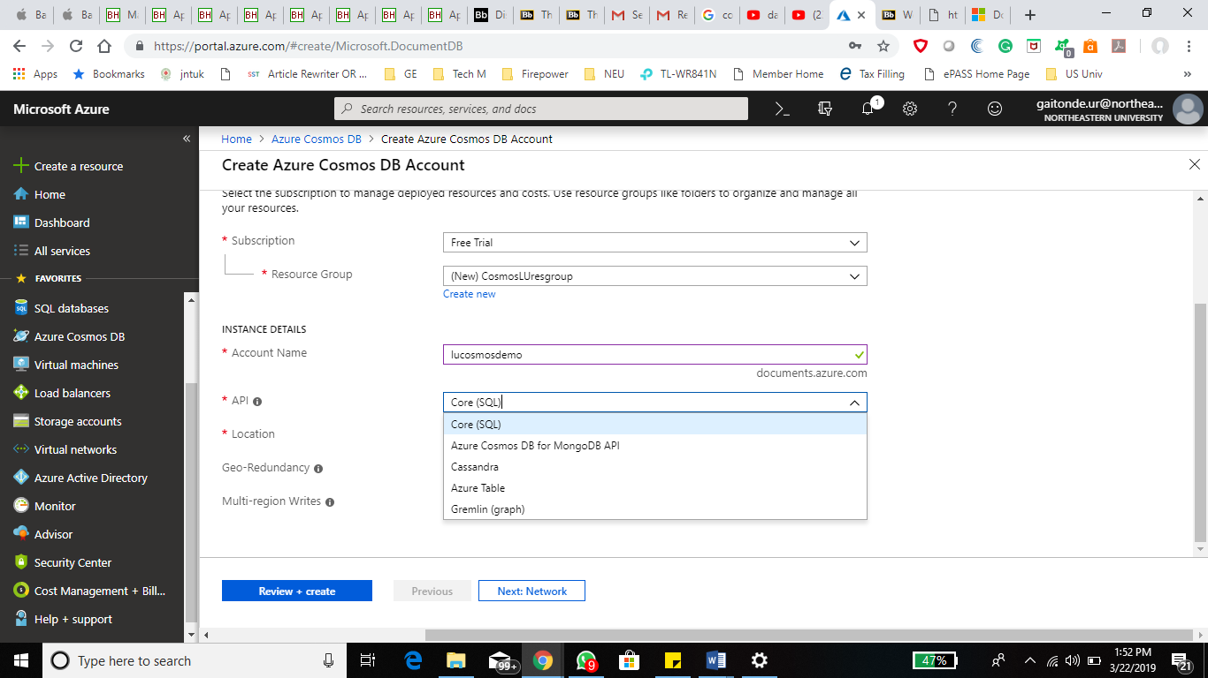

Cosmos DB provide plant base synchronization option which can be enabled by setting up Geo redudancy option which creates replicas of the existing DB across globe.

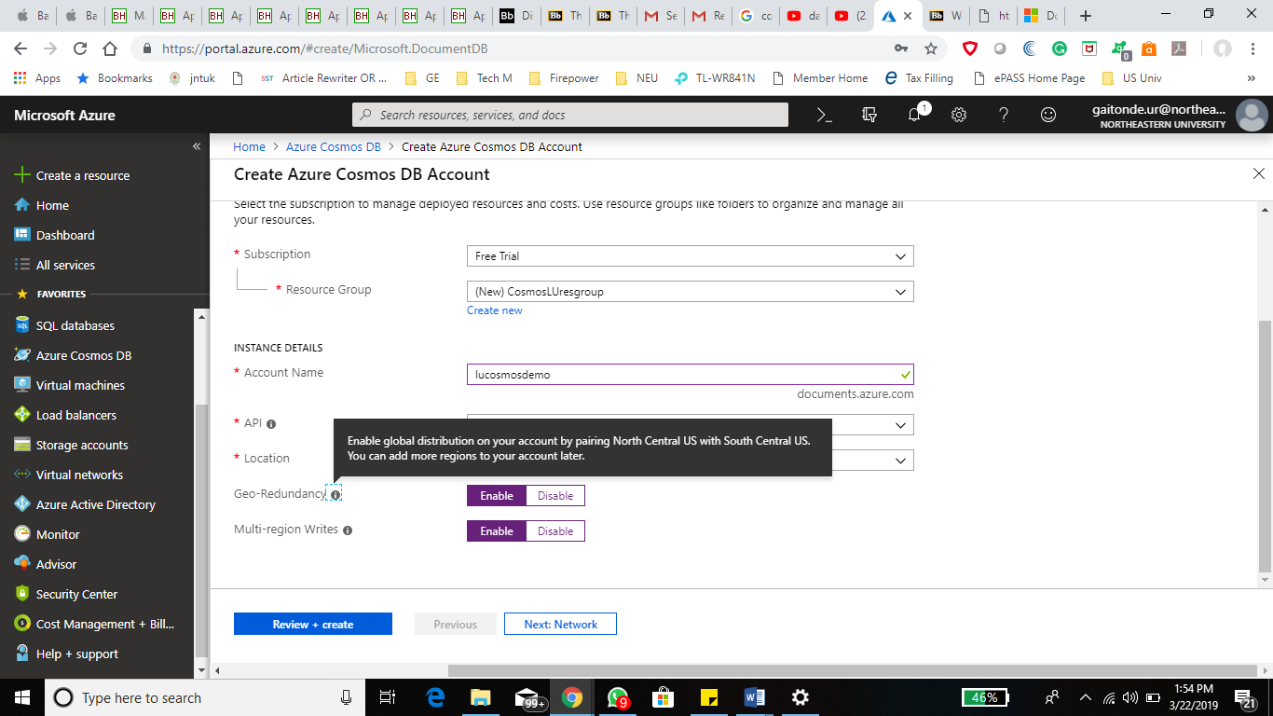

Mutli level writes allows us to increase the availabilty of the primary database.

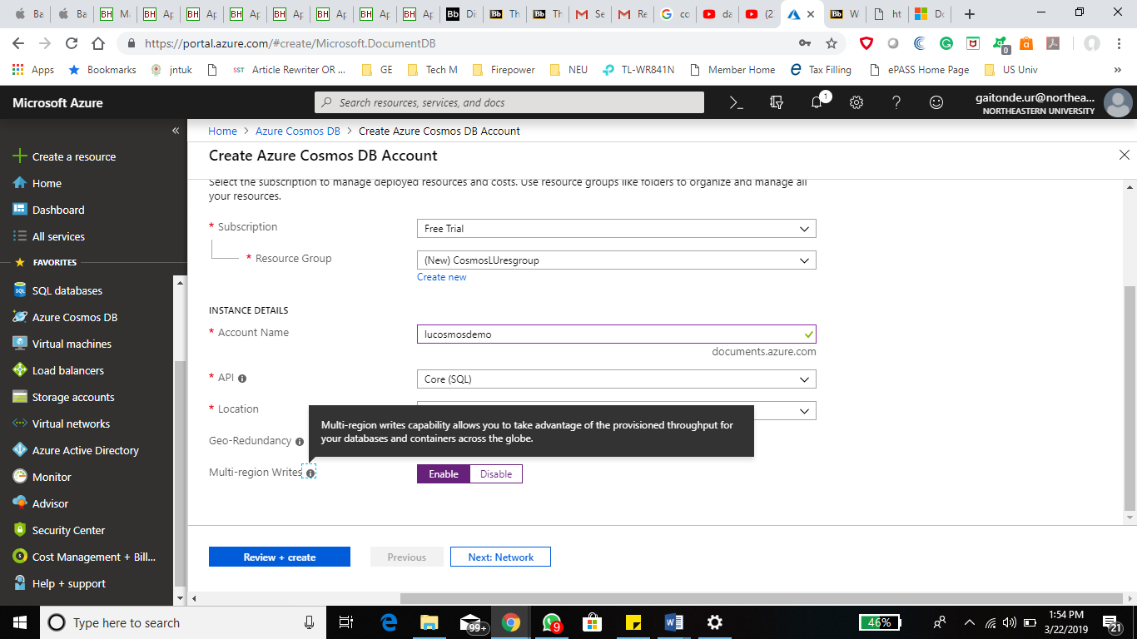

Enabling Geo Redundancy and Multi Region writes for best performance of the database.

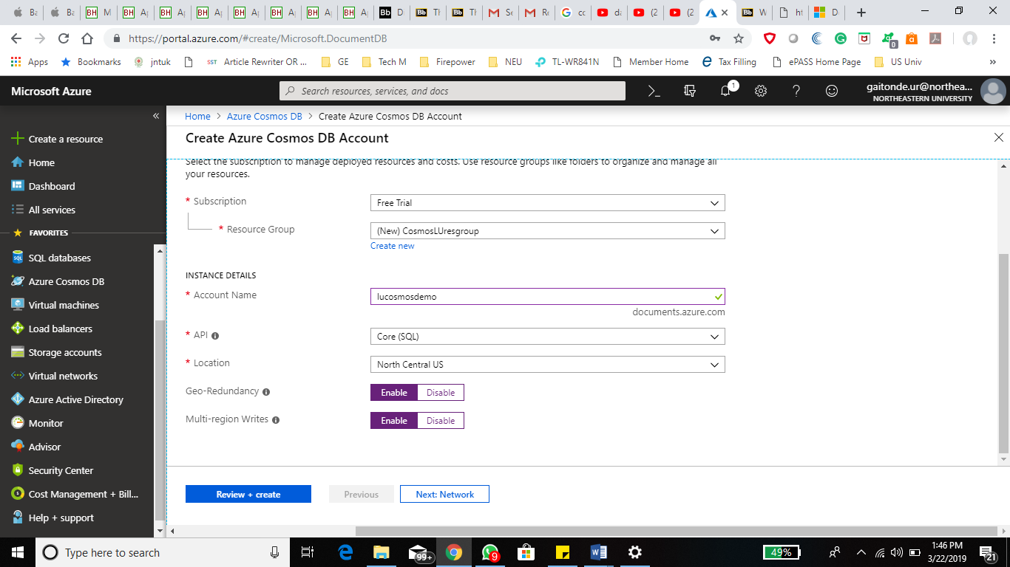

Creating a sample database on cosmos DB.

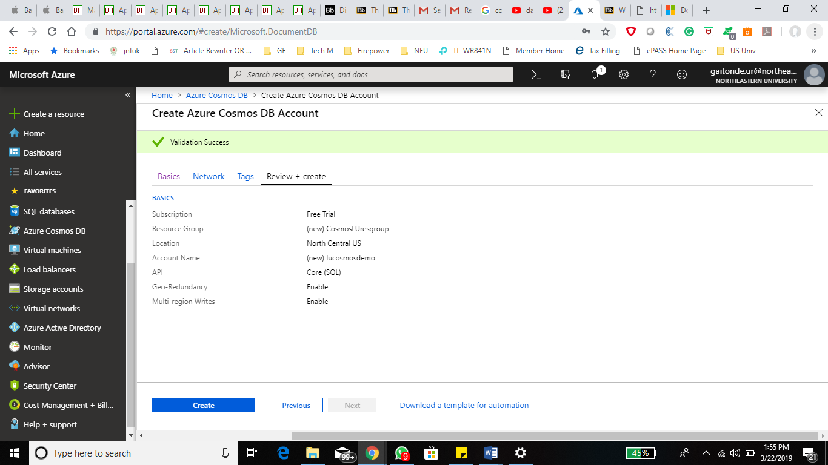

Deployment of the sample database (lucosmosdemo) is in progress.

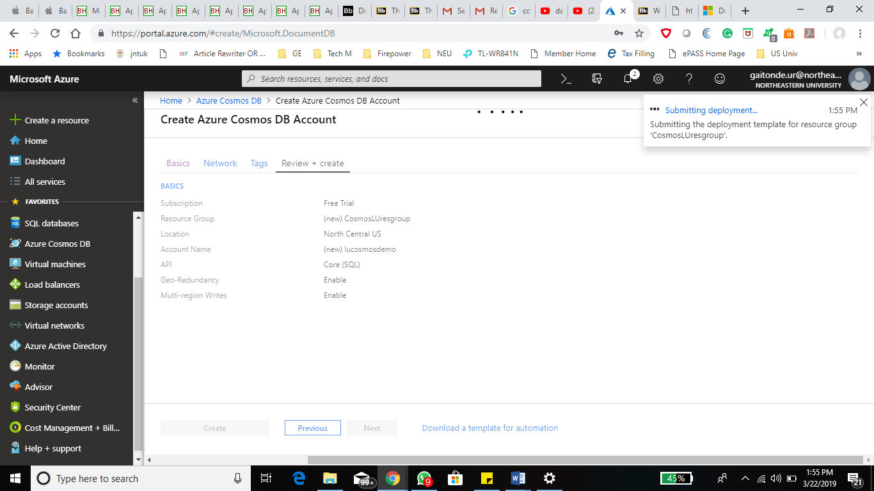

Deployment of lucosmosdemo is completed.

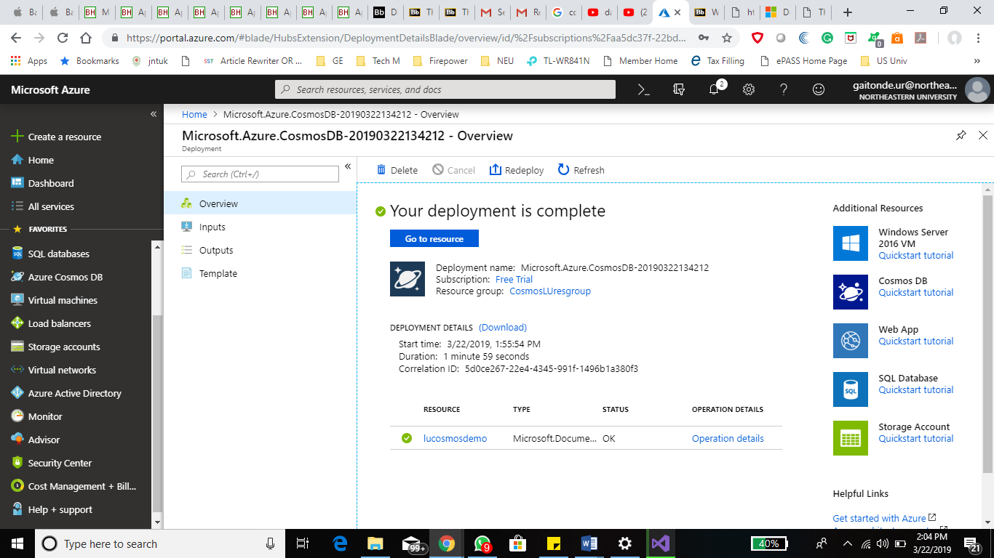

Home page of ‘lucosmosdemo’ database.

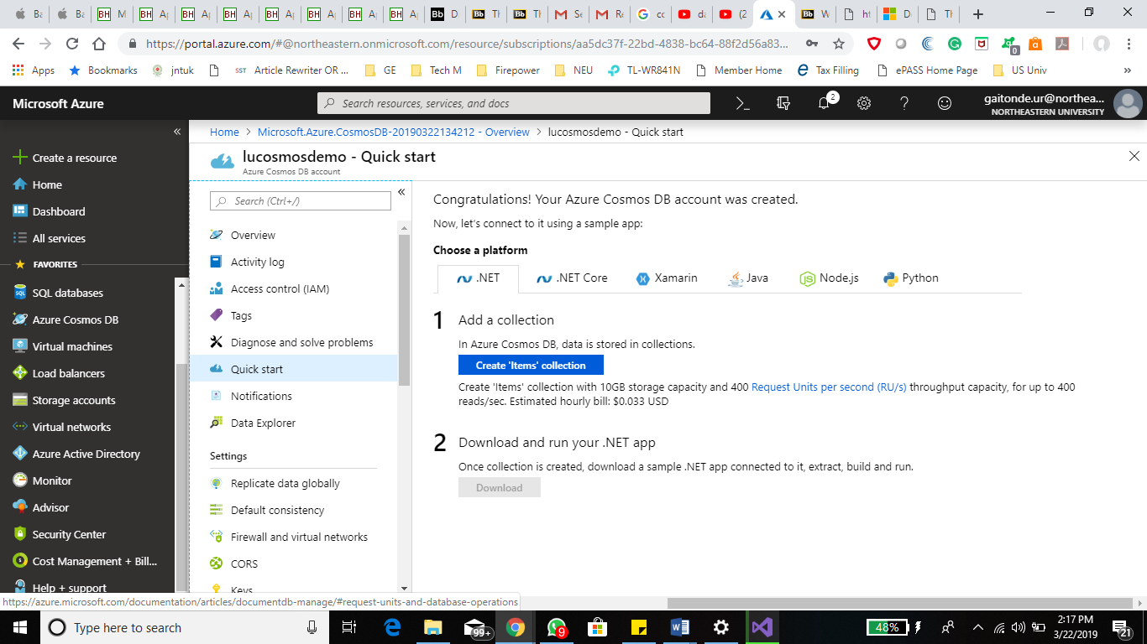

Now I will try to import a sample database into cosmos DB using Document DB migration tool.

Downloading Document DB data migration tool:

Google > Document DB data migration tool> download

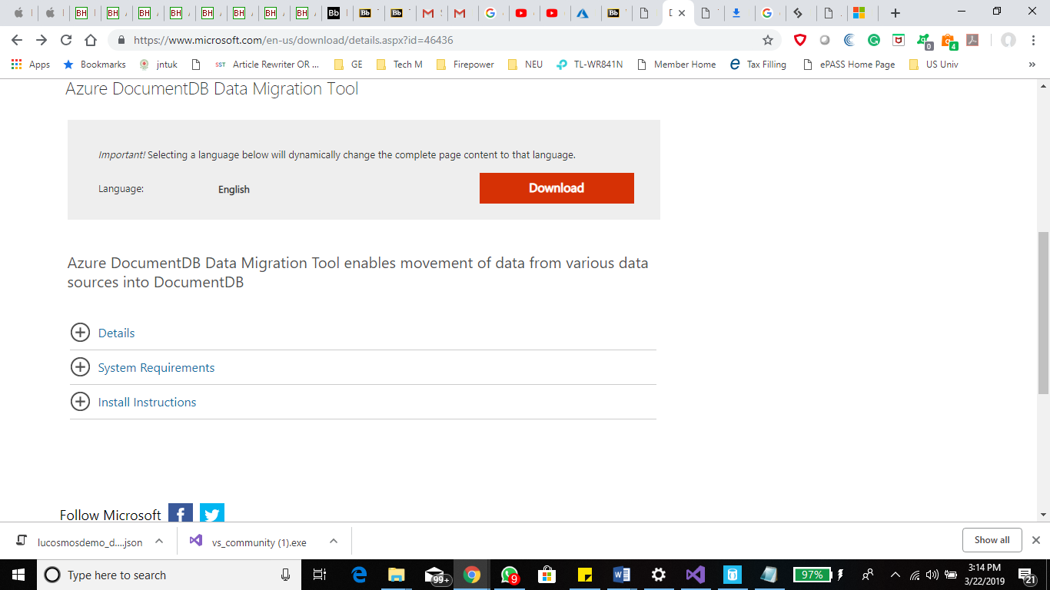

Selecting the required files:

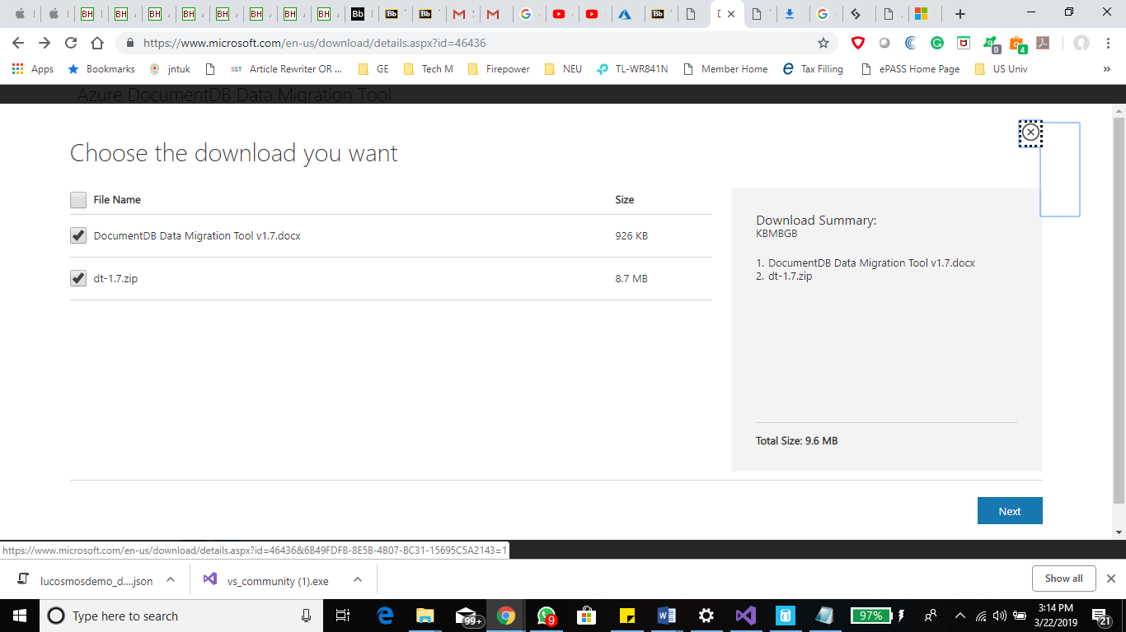

Downloaded the documentDB data migration tool.

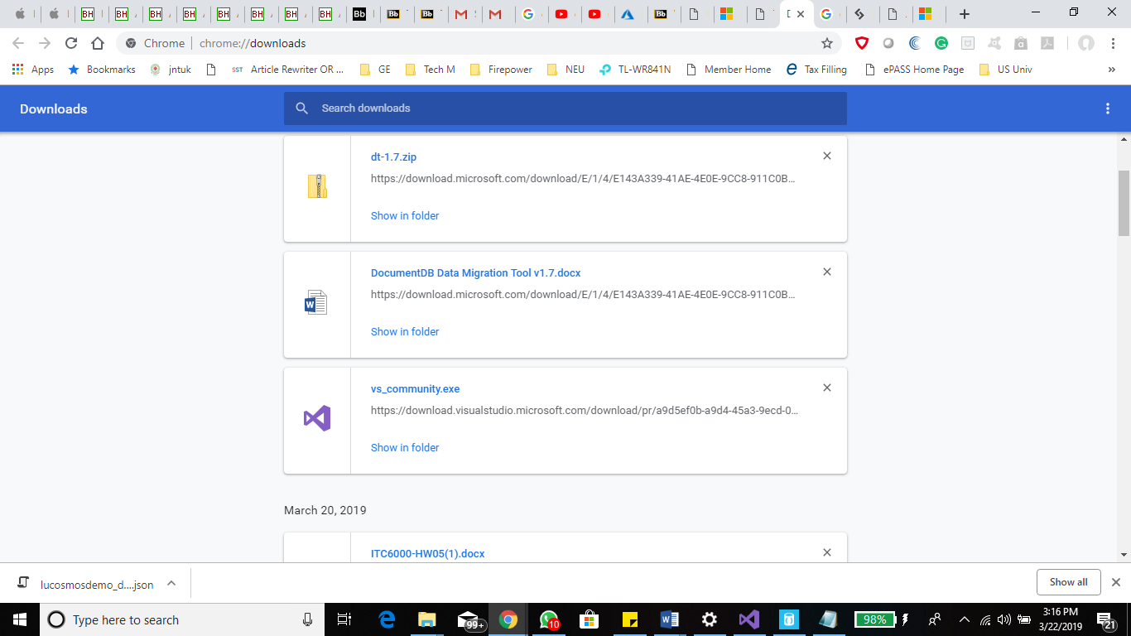

Run dtui.exe file to access the graphical user interface of the documentDB migration tool.

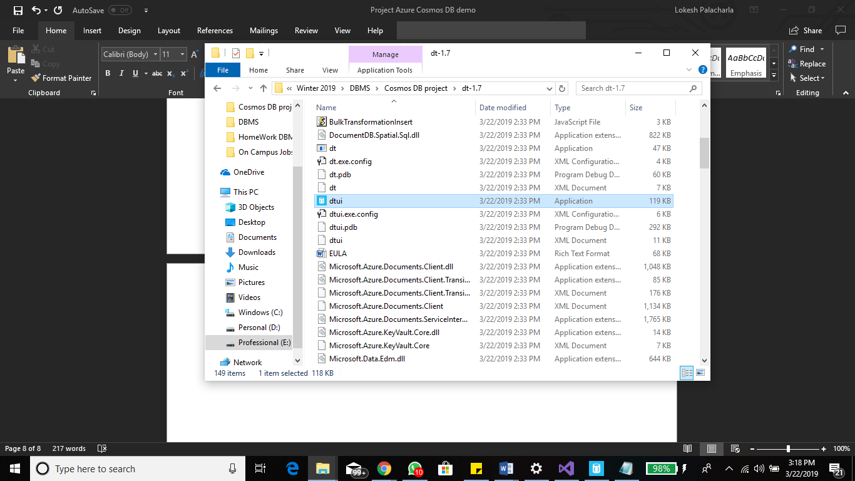

Home screen of the Document DB data migration tool with a menu on the left side.

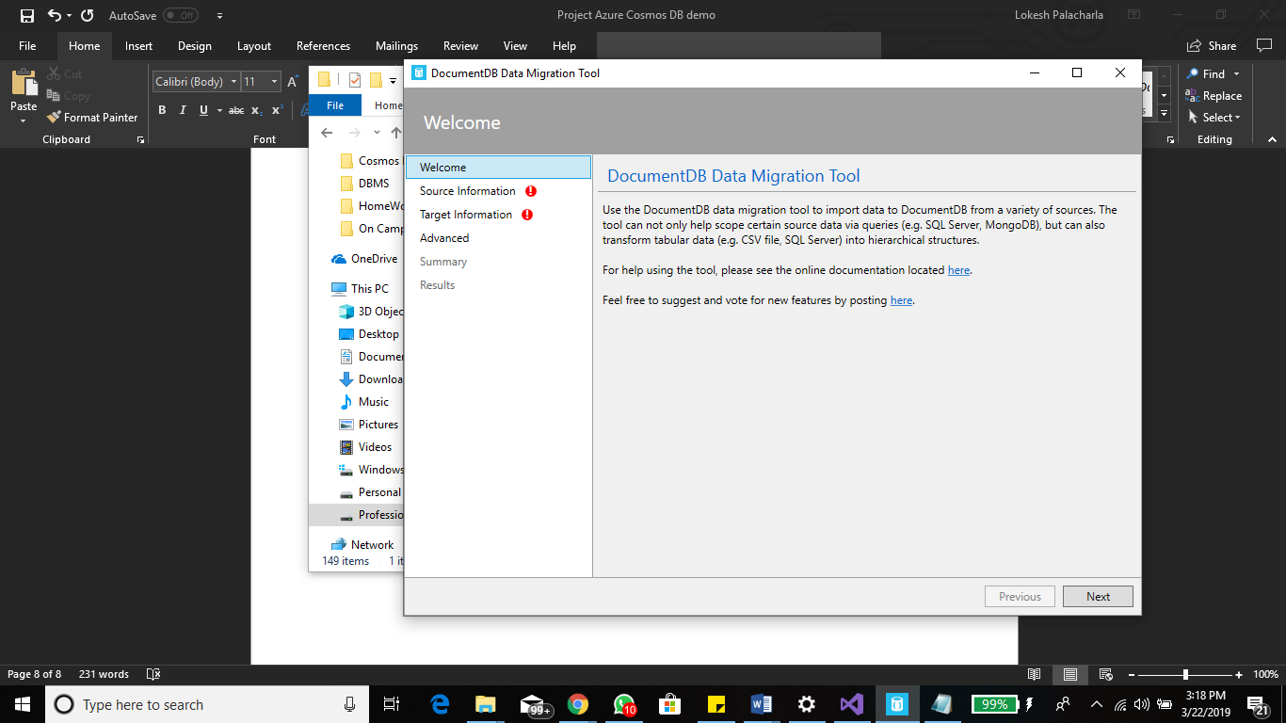

Source Information: We need to define the source file which needs to be imported.

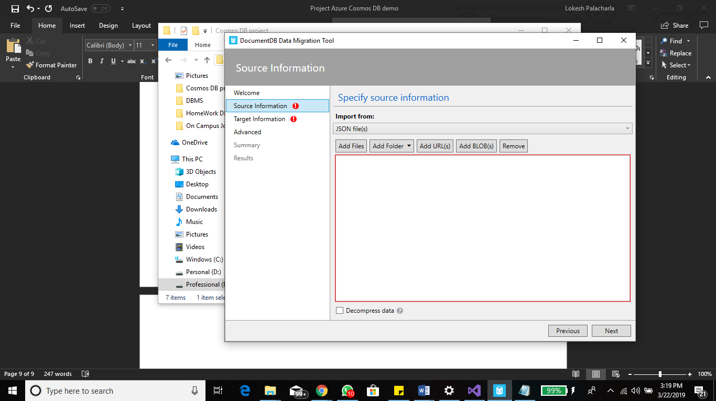

Created a sample products data in JSON format which we will import into the cosmos DB.

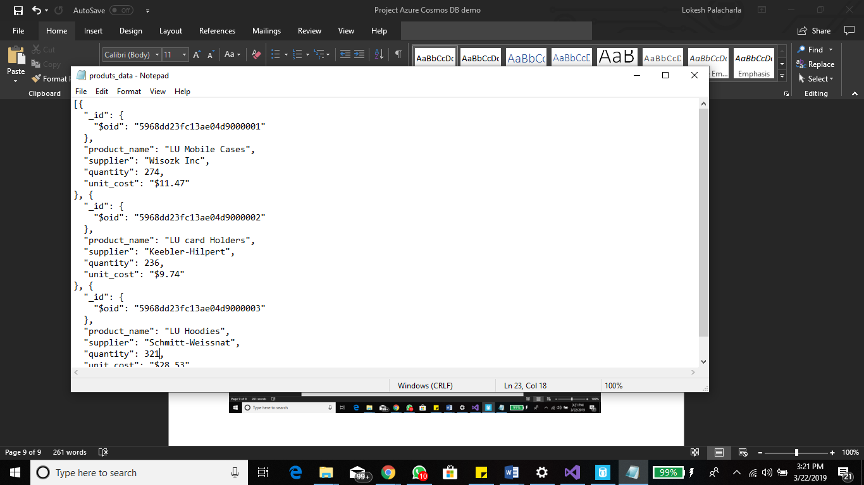

Browsed and located the JSON file with the sample product data in the data migration tool.

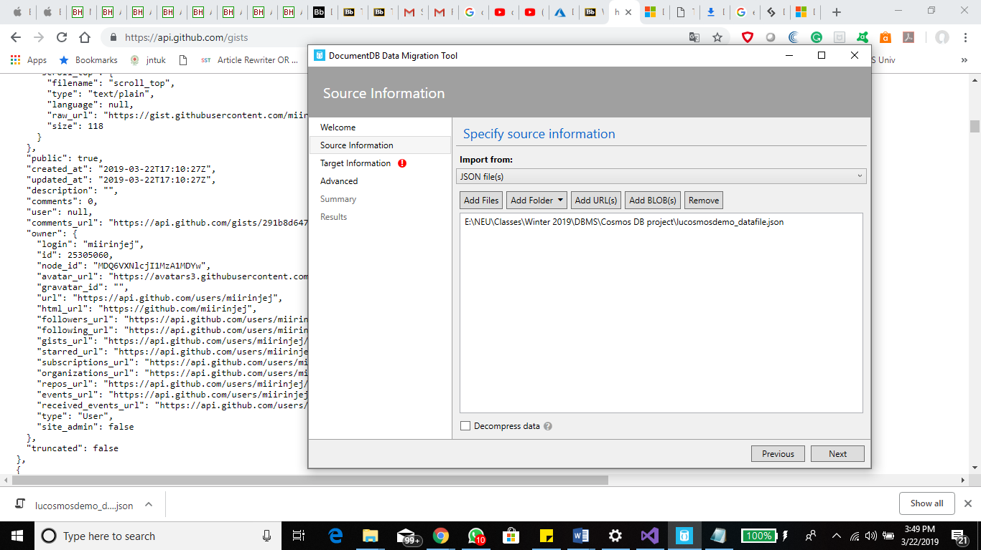

We need to specify a target database which stores the data being imported.

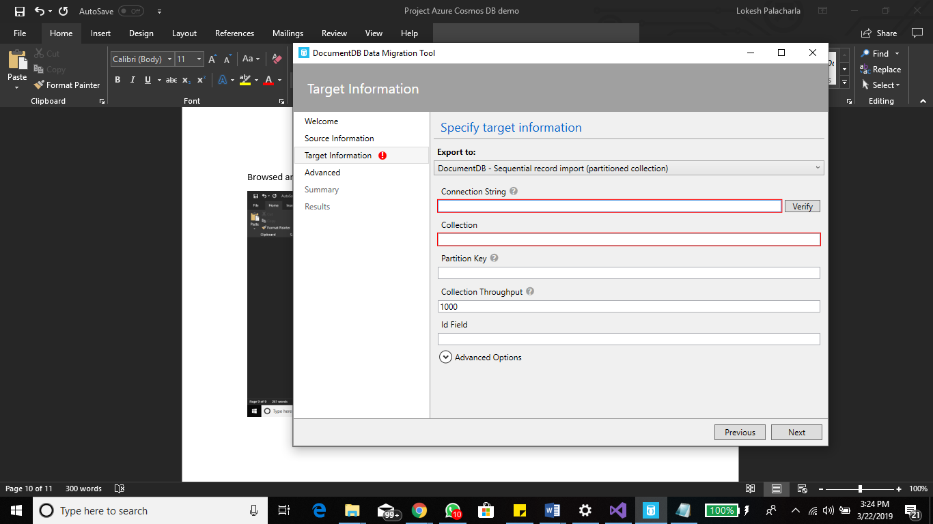

Connection string: This is used to connect the cosmosDB which we created.

General Syntax: AccountEndpoint=<CosmosDB Endpoint>;AccountKey=<CosmosDB Key>;Database=<CosmosDB Database>;

Customized Syntax:

AccountEndpoint=https://lucosmosdemo.documents.azure.com:443/;AccountKey=88wILG5ApDXMdPhBwGtzmF8CdfouuYl5xk4ahA4IKbAJar5XQI3Ptys5y1h0IxqoiAnzVs4VBK1ayfU0M3qA7A==;Database= lucosmosdemo;

We can get the above data required for connection from the Keys option available for the database as shown in the below snapshot.

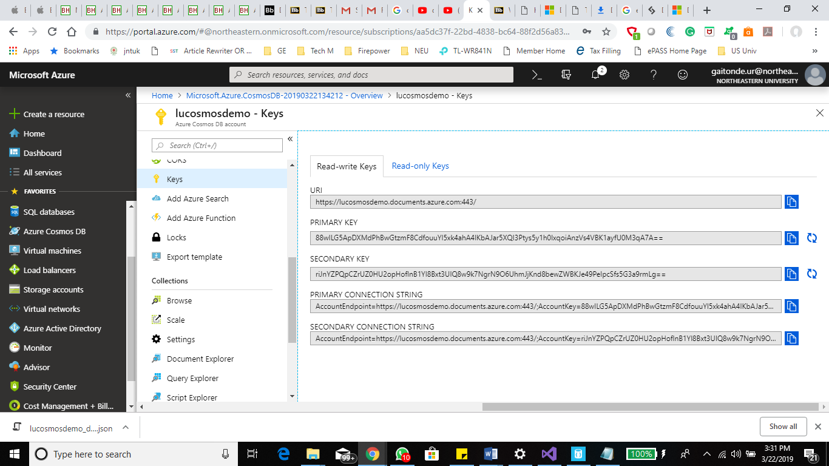

Connection to lucosmosdemo Database was successful.

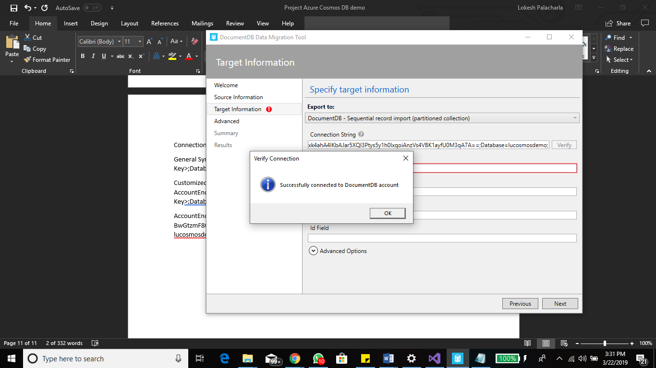

Specifying the required details of the target database like collections, in our case we created a new collection: lucosmoscoll

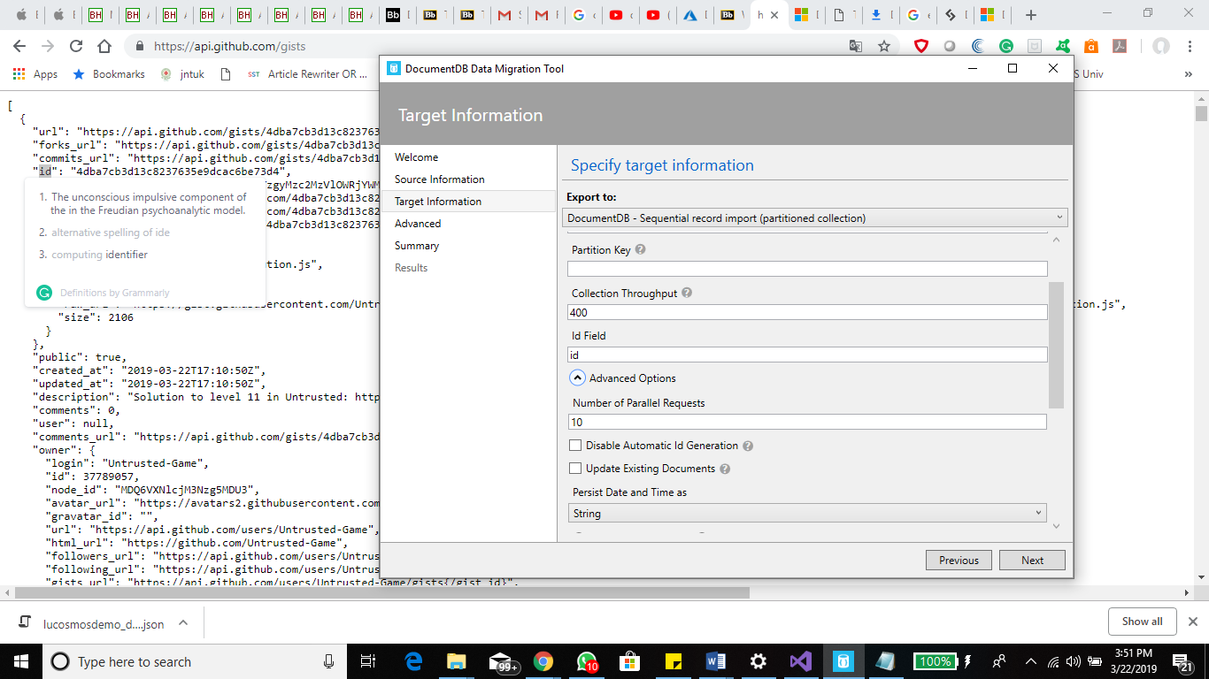

Click on Import the data into cosmos DB.

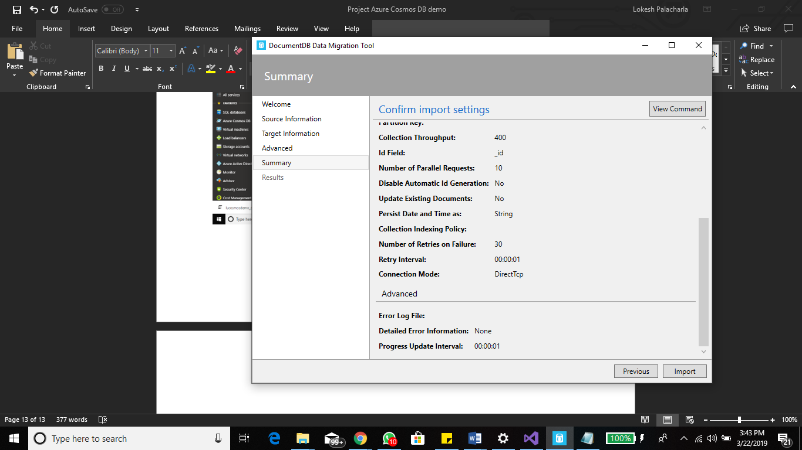

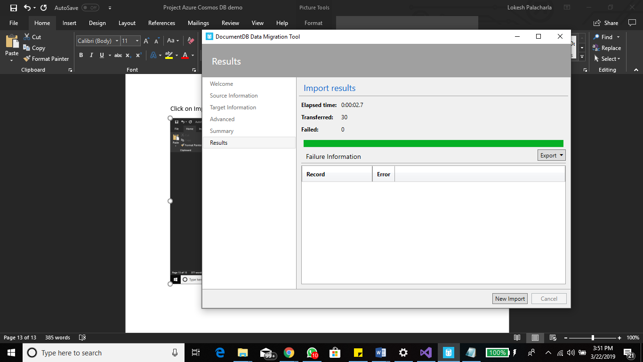

We can check the data which we imported in the data explorer:

Data Explorer > lucosmosdemo > lucosmoscol > documents > New SQL query.

Select \* from c

where c is the alias name for the collection (lucosmoscol) which we have created.

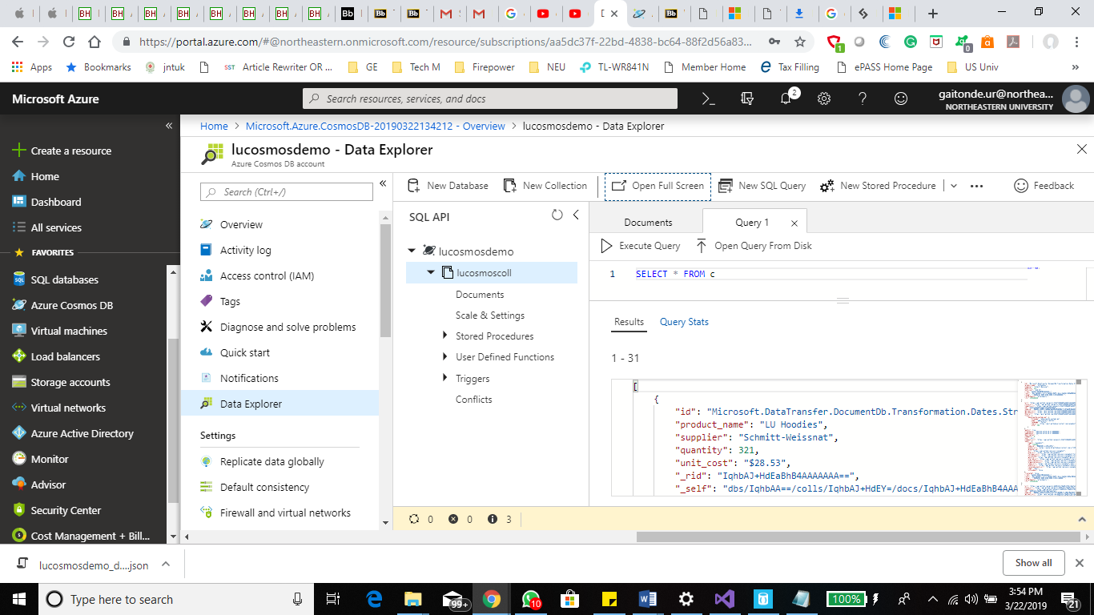

We can also check the data which we imported in the SQL explorer:

SQL Explorer > lucosmosdemo > lucosmoscol.

SELECT \* FROM c

